# BACKSTAGE Software Platform

URL: https://backstage.mit.edu/

* If you need an upgraded (staff) account, please contact [cjshaw@mit.edu](mailto:cjshaw@mit.edu)

* Warning: this platform is experimental and constantly changing. Bug reports are welcome—email me or file them here: http://github.mit.edu/oeit/backstage/issues?state=open

TABLE OF CONTENTS

BACKSTAGE Software Platform 1

GOALS 1

RESOURCE LIBRARY 1

COLLECTIONS 2

Copy a class 3

Edit / re-order existing content 5

A/B Test interactions 6

Adding new content 10

Saving your changes 19

Download to edX 20

Upload a new version 21

LEARNING OBJECTIVES 23

UPLOAD COURSE 23

## GOALS

**Backstage** allows MIT faculty, TAs, and MITx fellows to re-use digital content from multiple sources. Versioning of problems and courses enables tracking of content usage, eliminating the lack of traceability with copy-and-paste.

## RESOURCE LIBRARY

This feature is under revision. We are exploring the appropriate use cases for how to interact with all the resources in Backstage.

## COLLECTIONS

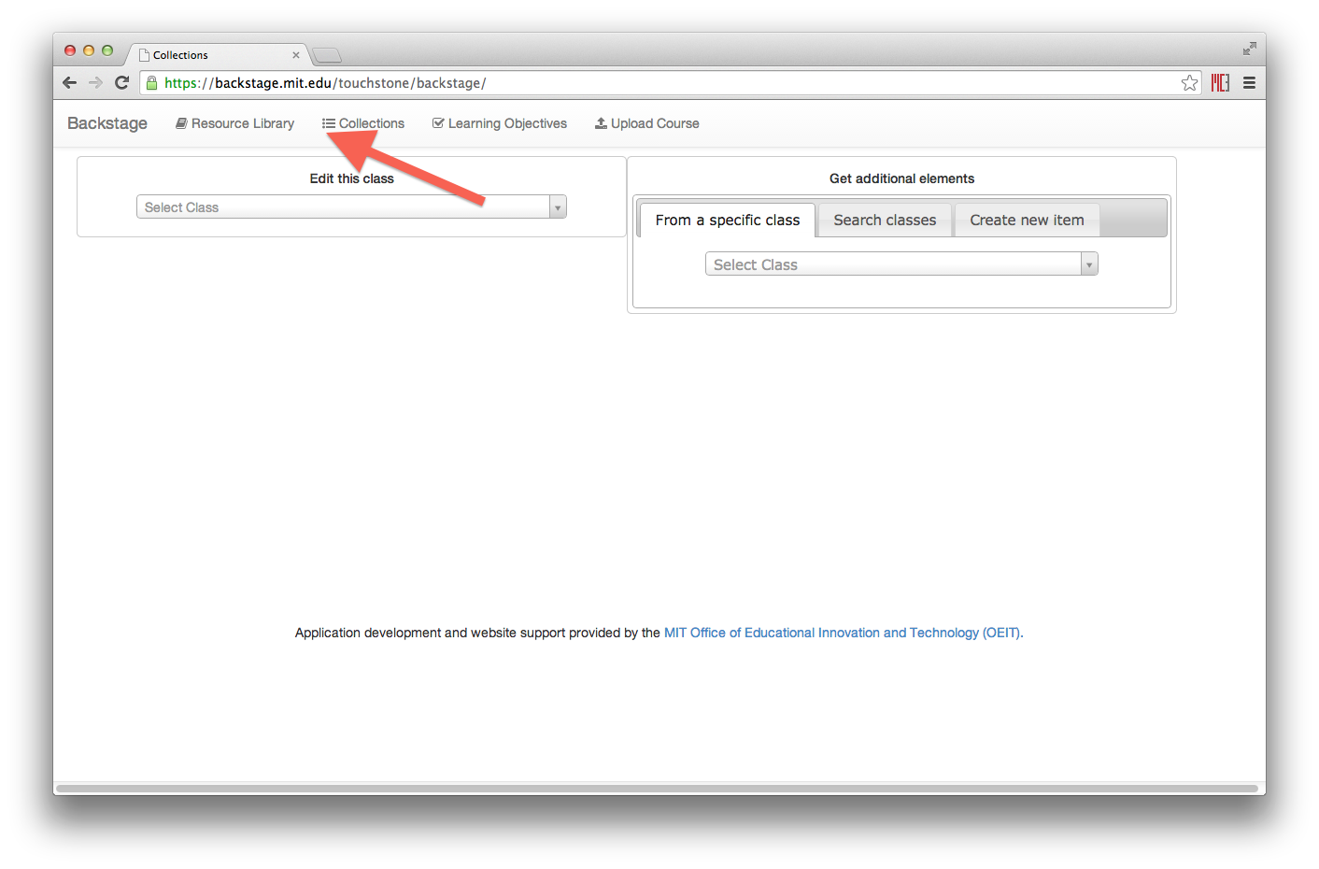

The Collection tab consists of an Edit canvas on the left and a Source canvas on the right. The class you want to edit can be selected from the left-hand dropdown menu.

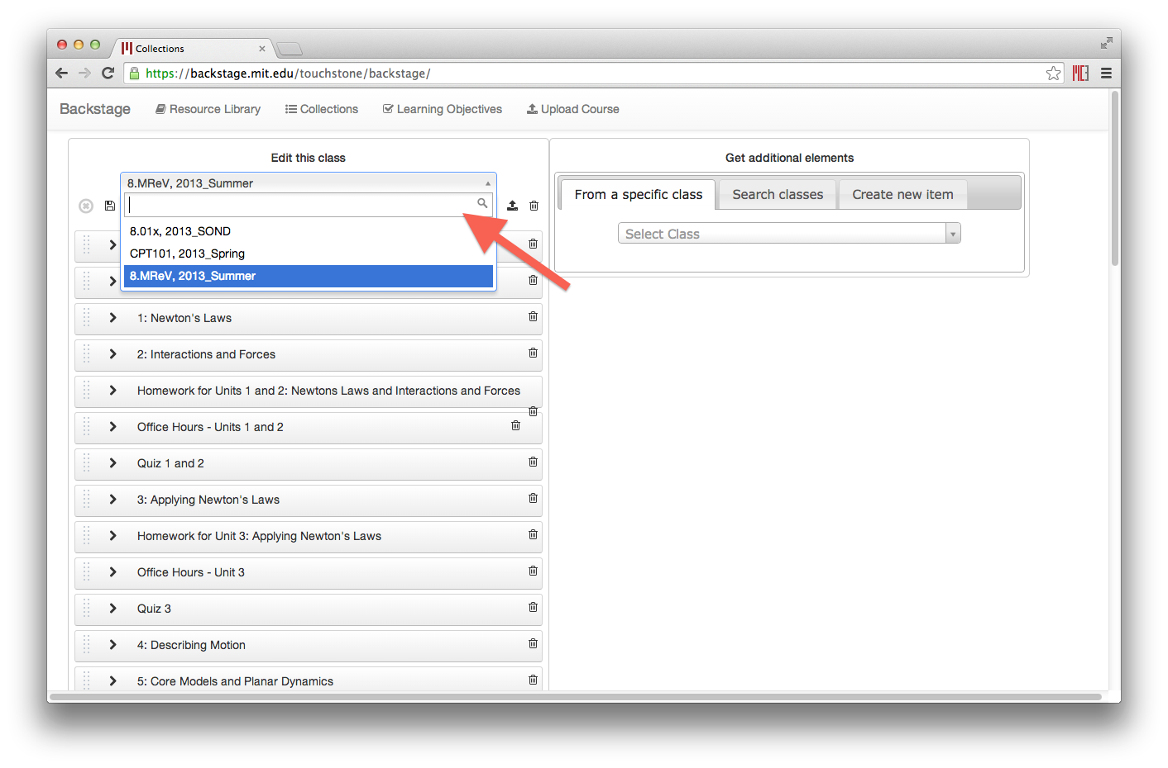

### Copy a class

Sometimes you may want to use an existing class as a template for another. To do this, first open the original class, then click the ‘copy’ icon.

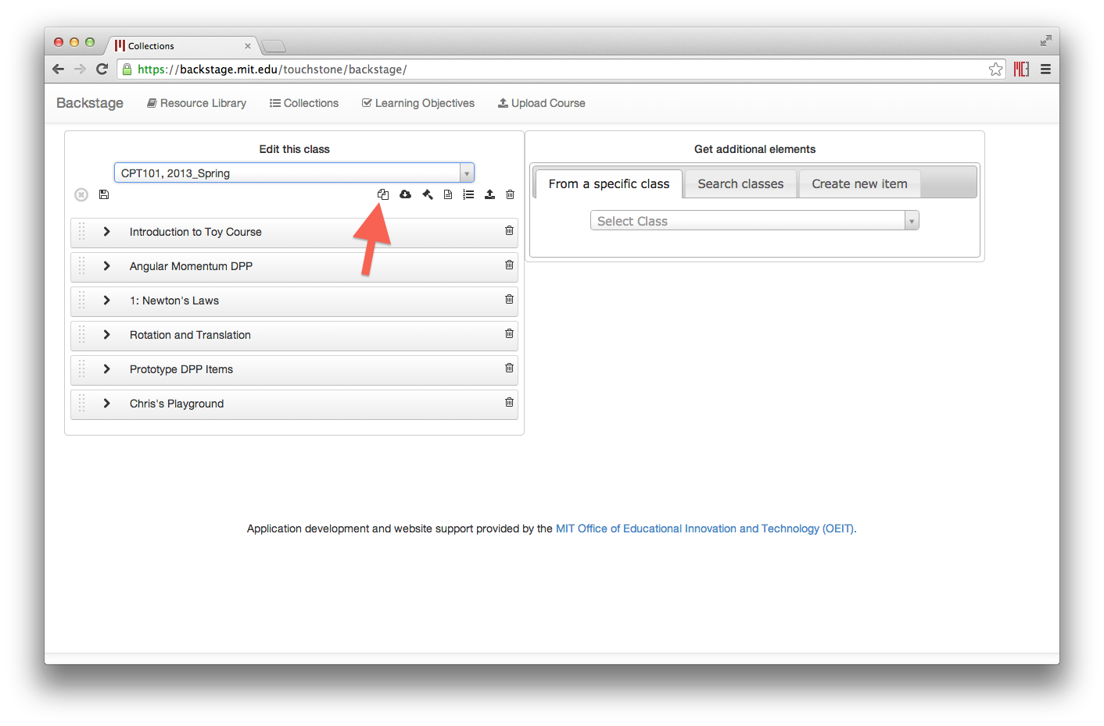

You will then be prompted for the new class name and semester.

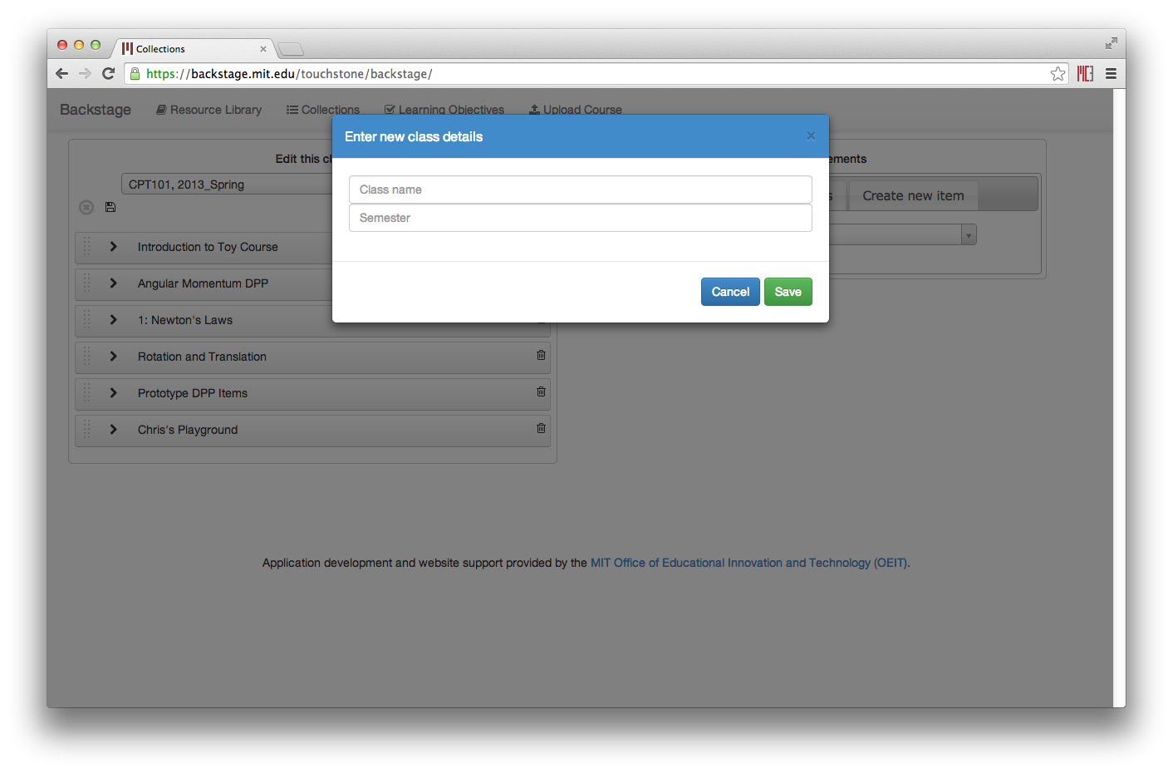

Saving this will create a new class for you to edit.

### Edit / re-order existing content

Course elements can be expanded, and bottom-level items like HTML content and problems can be previewed by hovering your mouse over the “eye” icon.

You can re-order elements by dragging the handles on the left of each box.

Deleting an element will remove it and all of its children from the course.

You can also type directly into the box of any item to change its display name—what the students will see.

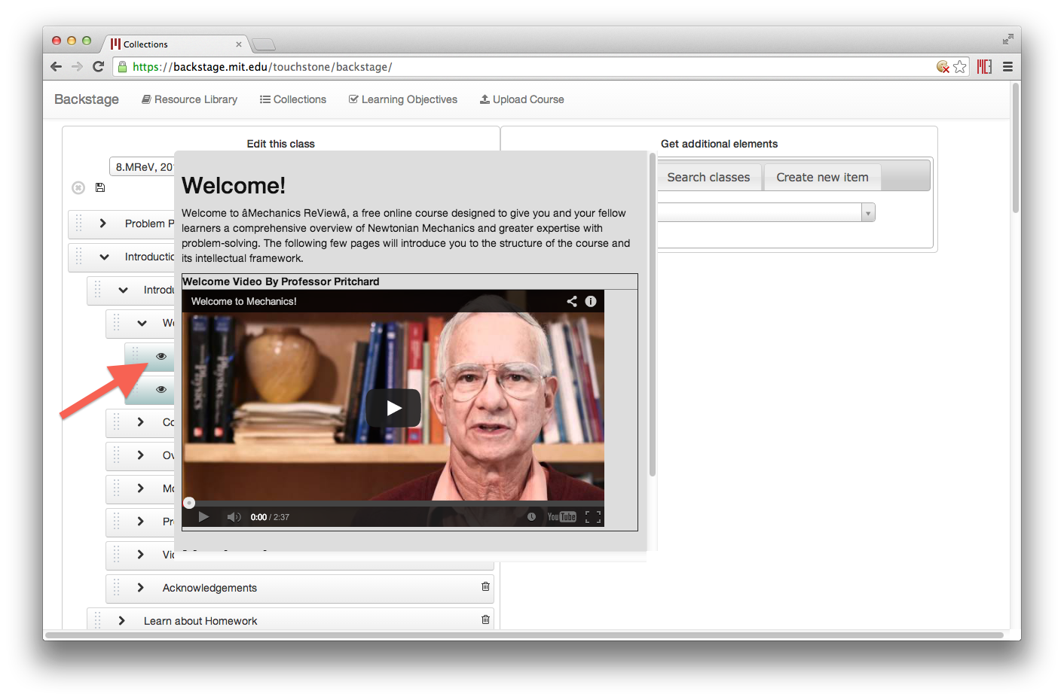

### A/B Test interactions

For A/B tests, you can change its user partition id directly in the course tree, by clicking on the existing ID.

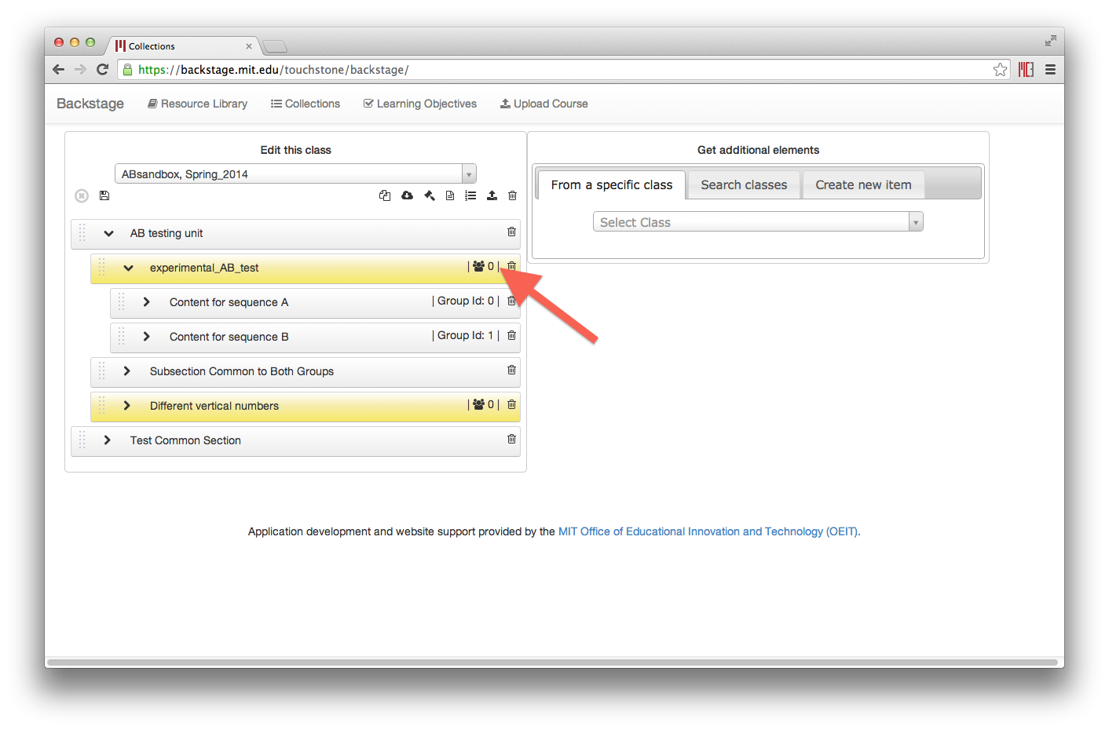

Note that only user partition ids from the policy file are available. If you need to, you can define them first by clicking the user policy icon.

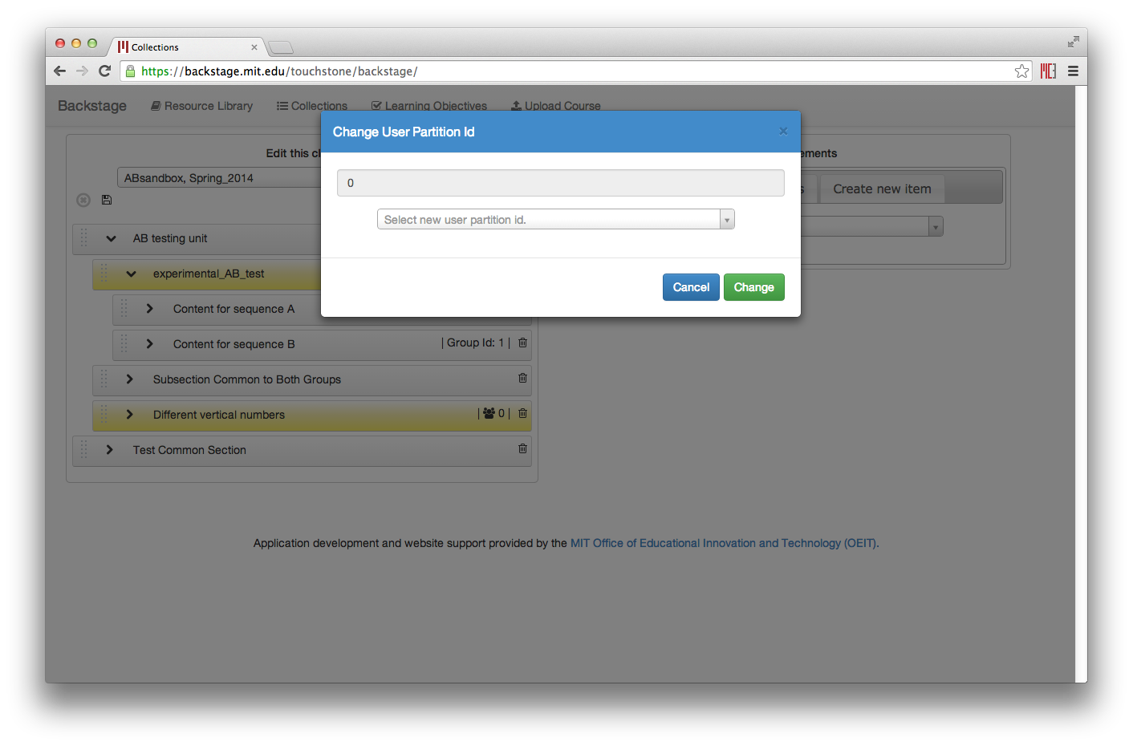

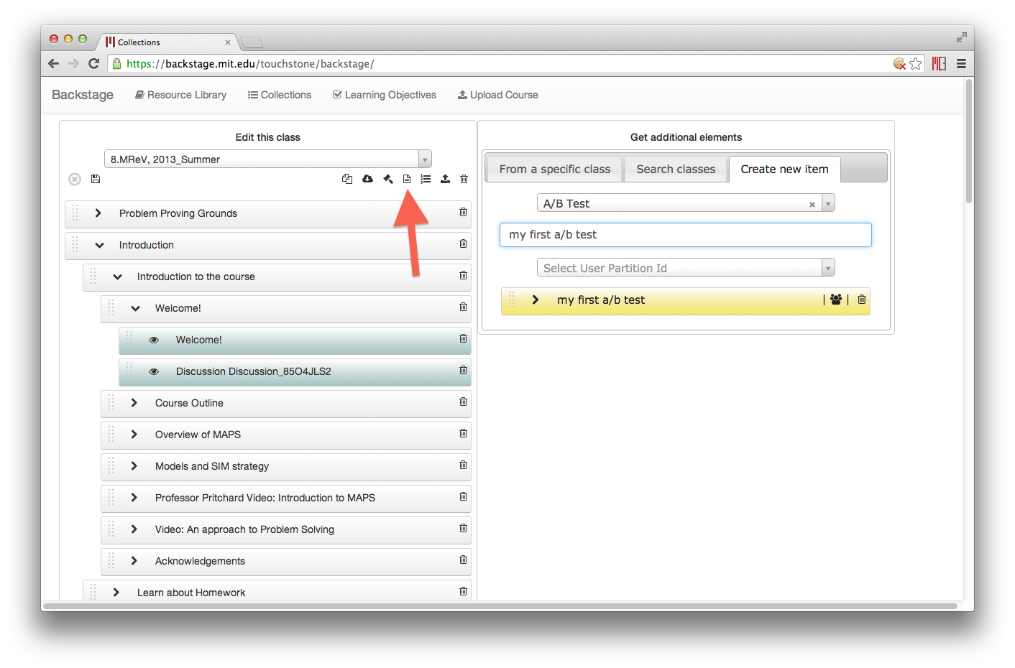

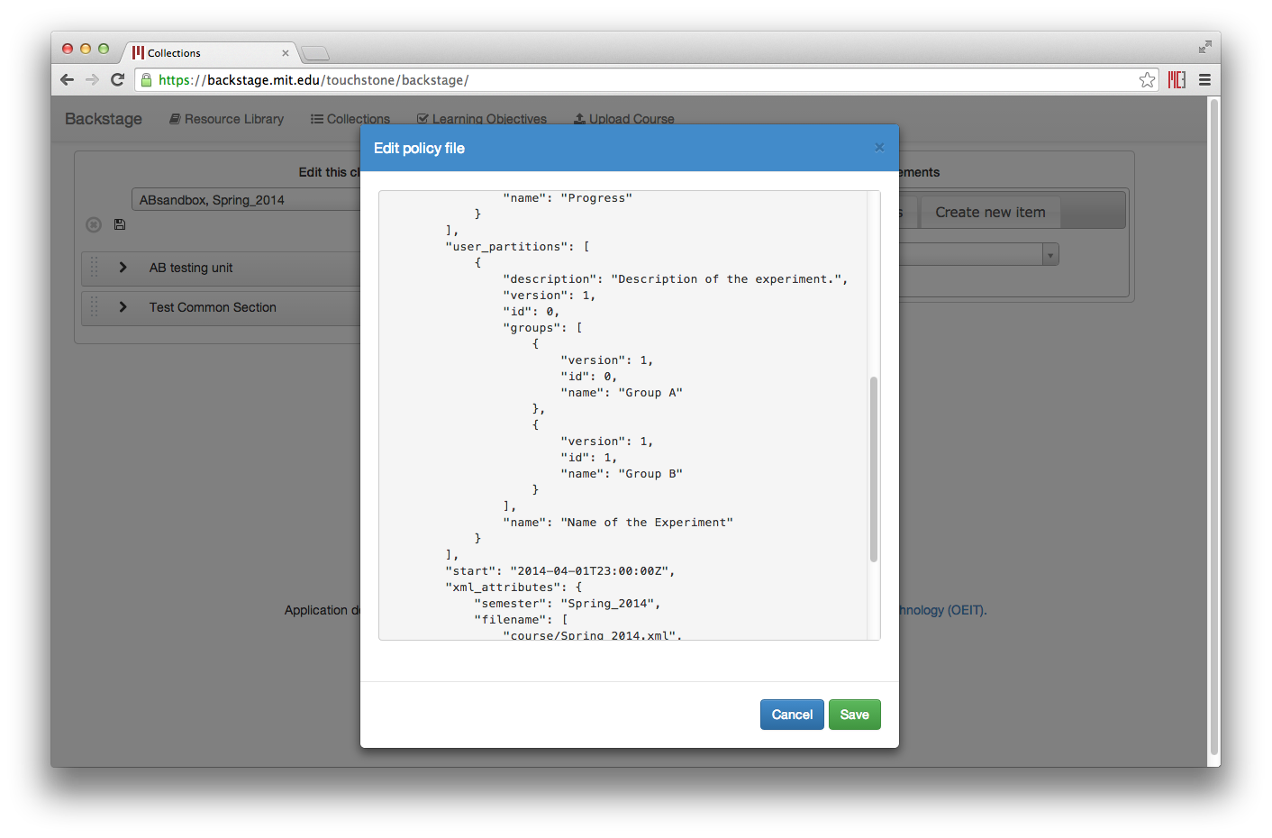

For A/B tests, you also need to make sure the right groups get the right content. To assign group IDs, you just need to reorder the elements under the A/B test. Whichever element appears at the top of the tree will be element 0, then element 1, etc.

### Adding new content

There are 3 ways to create new content in your course—they appear in the three tabs on the right-half of your screen.

#### From a specific class

If you know which class and which version you want to pull from, use this tab. A course tree will appear on the right—using the handles (left side of each box), you can drag any unit into the course on the left.

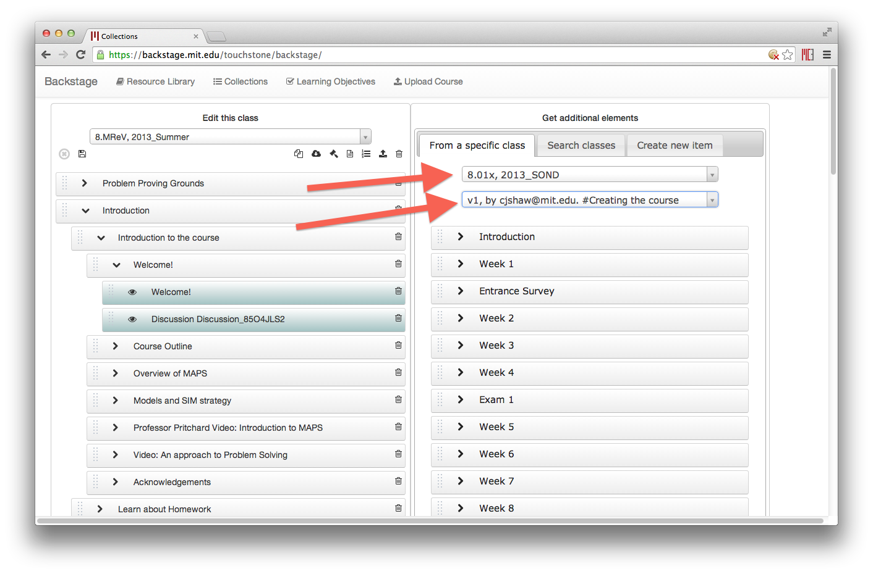

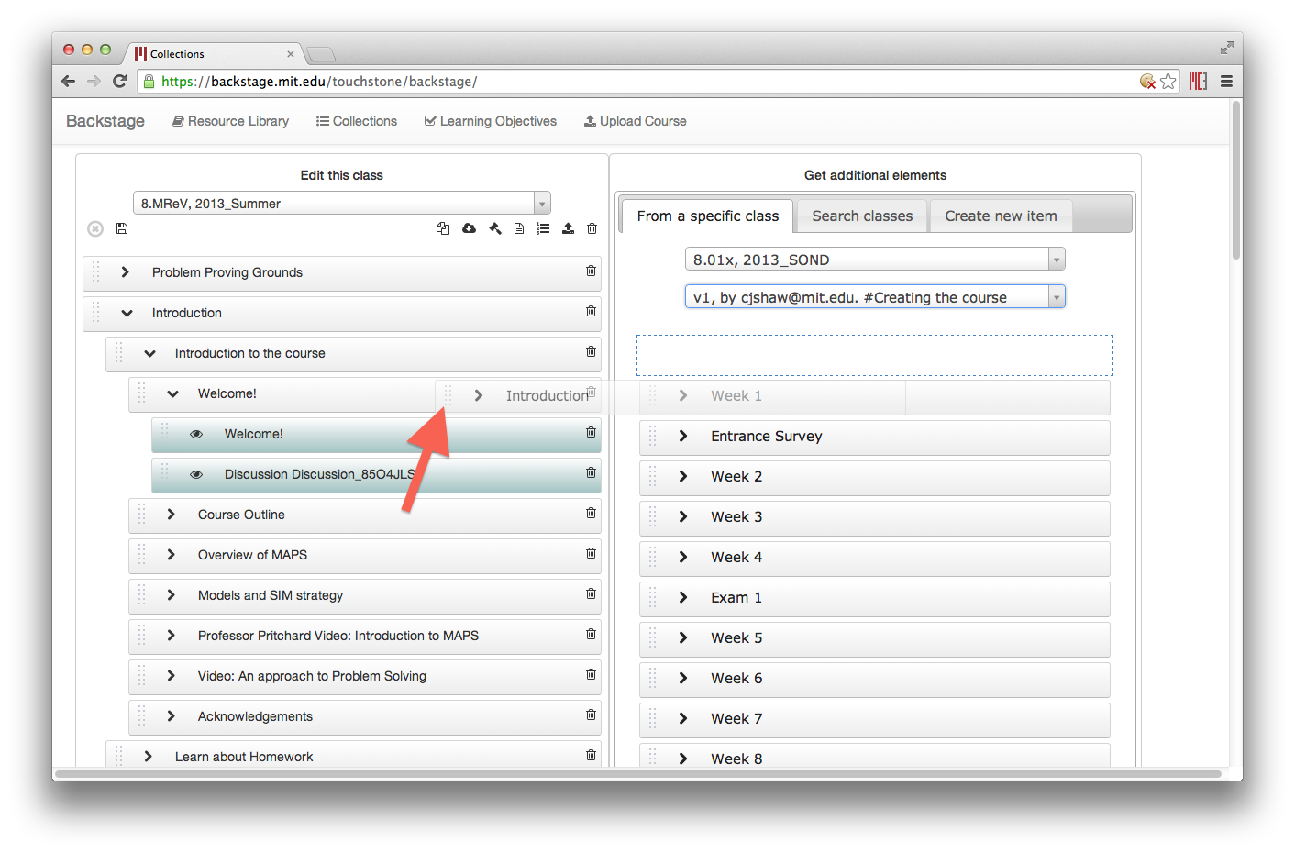

Note that dragging any item will also drag its children. So moving a chapter from right to left will also bring the chapter’s sequentials, verticals, and problems.

#### Search classes

The second tab works best if you have some idea of the content you want, but not where it is located. You can include multiple classes and search parameters, such as sequentials and problems. Results are shown in a table at the bottom.

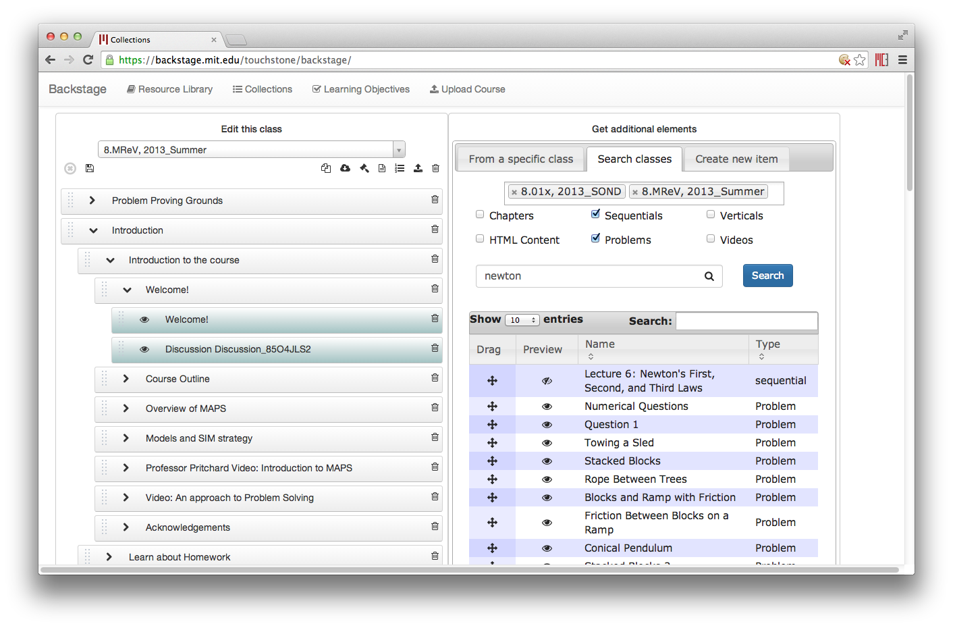

If an item is previewable, it will show an “eye” icon; if not (like a chapter), an eye with a slash icon will be shown instead. You can drag the item into your course by using the “Drag” handle on the left of each row. You can also search the results table using the Search box at the top of the table. Note that this search will only affect the results shown, and will also look in the visible parameters (name and type).

#### Create a new item

Currently this only works with new Units (chapter / sequential / vertical), and new A/B tests.

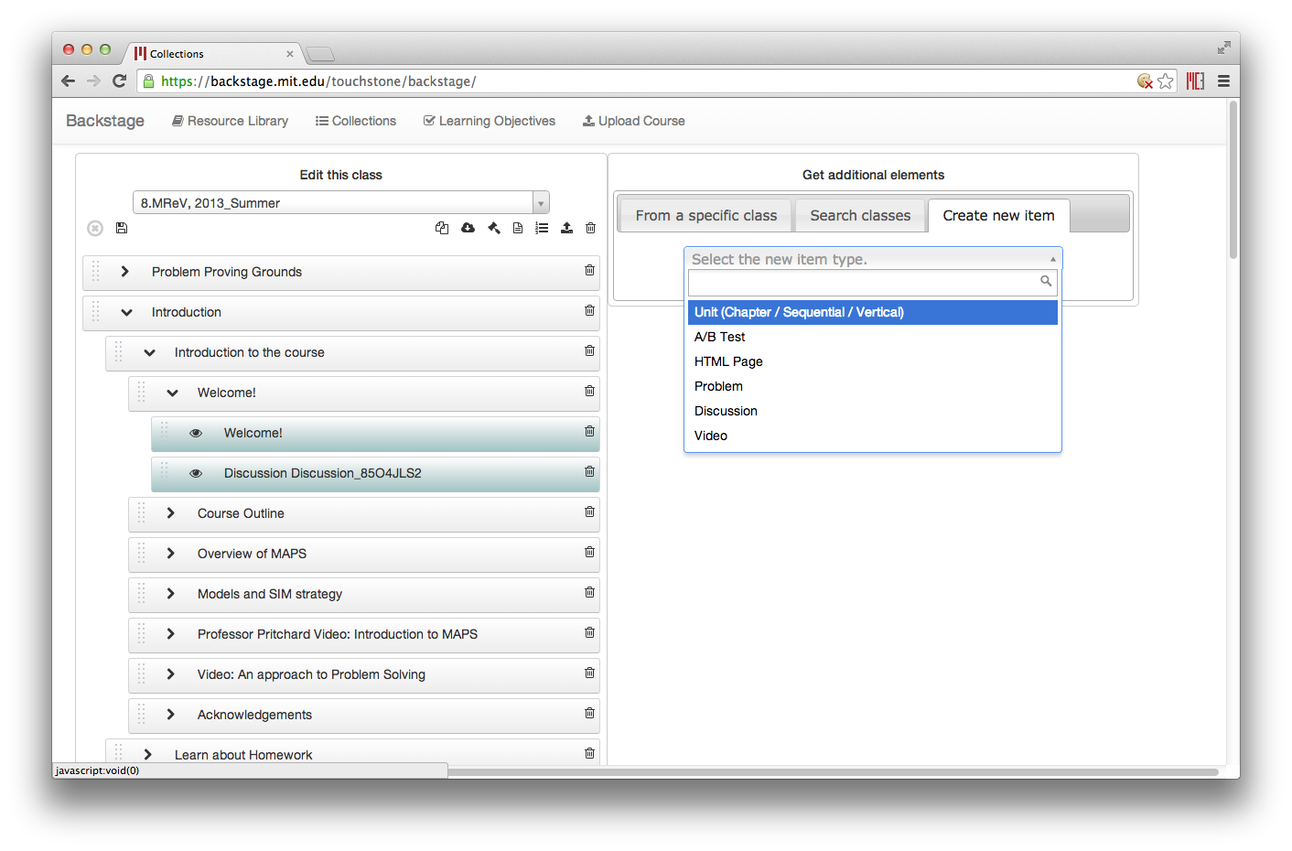

For a new unit, you can include the display name and if it should be considered draft / private (for verticals only). A draggable box will appear, which you can then place in your course.

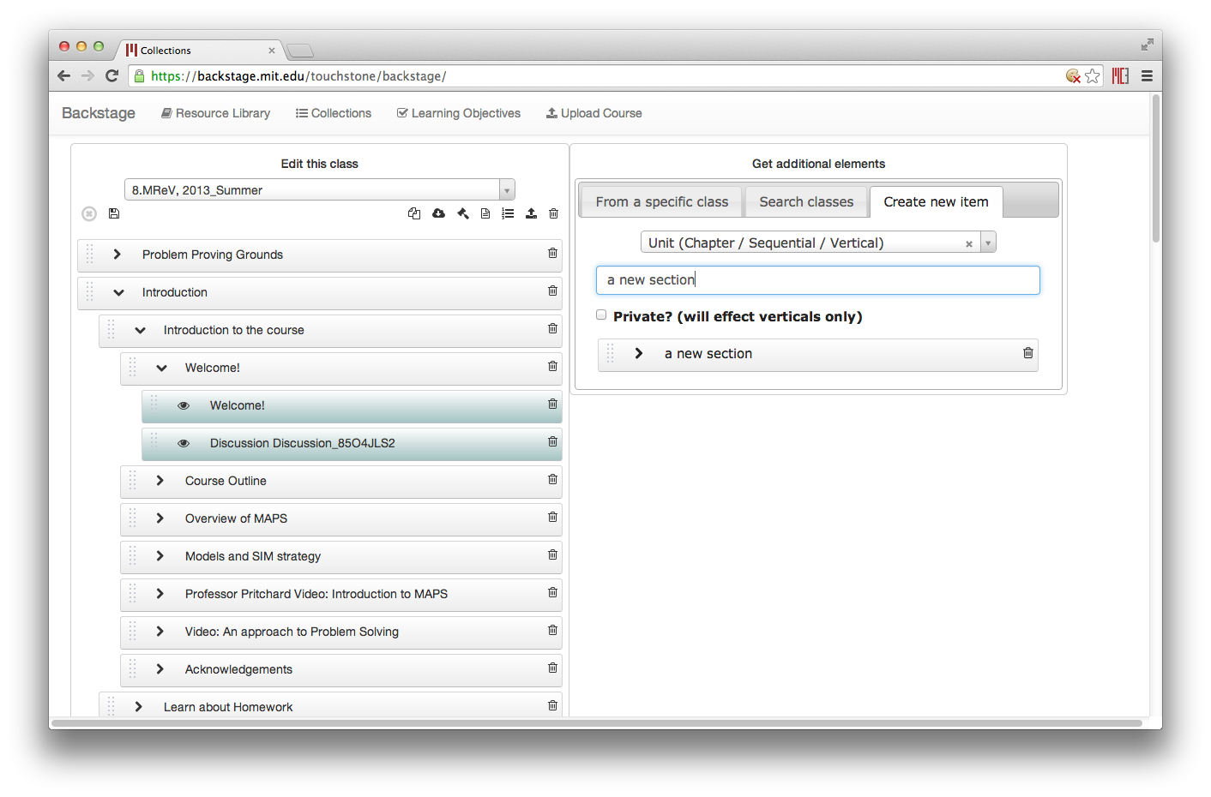

For A/B tests, the draggable box will be yellow. You will have to specify a user partition id from the dropdown box when defining the A/B test. 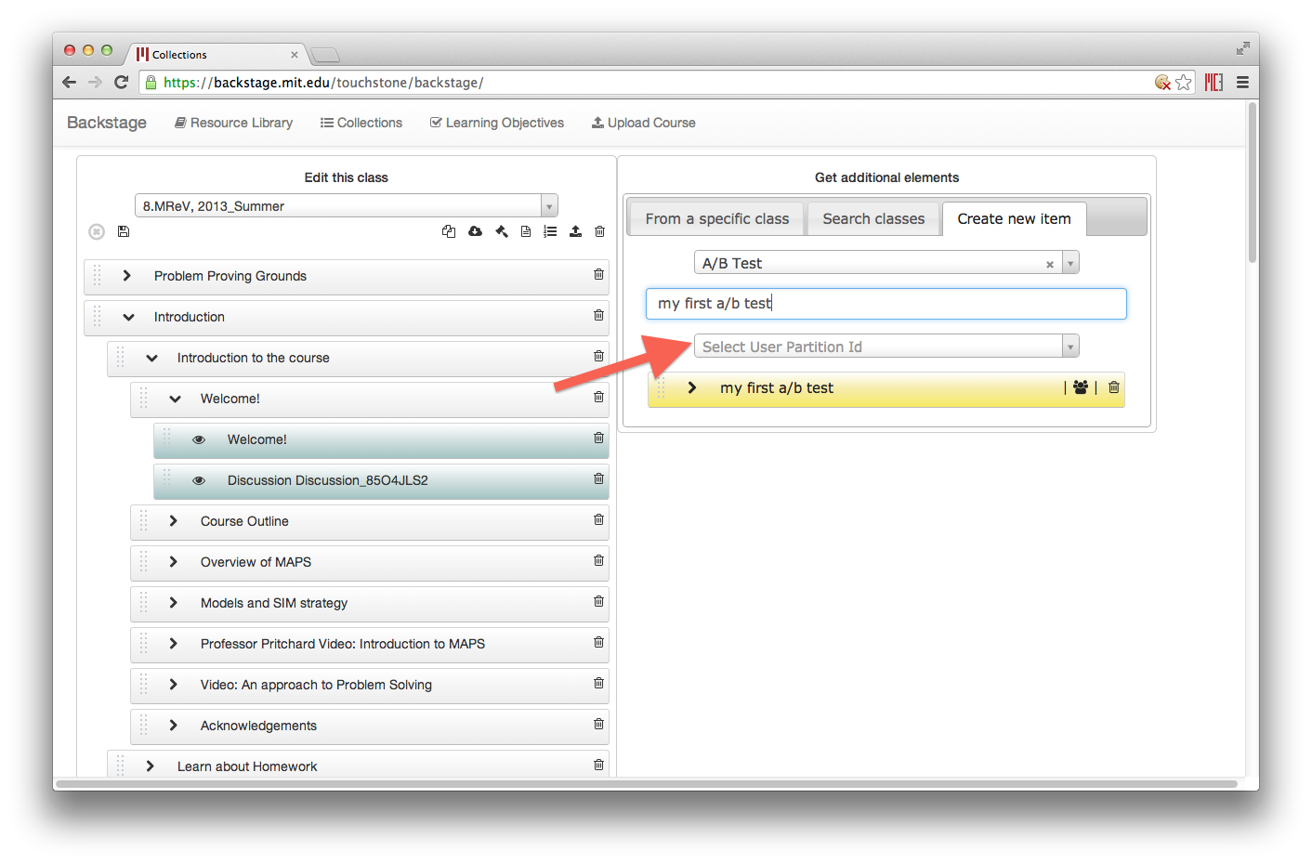

If no user partition ids are available, you will have to define them first in your policy file—edit this via the policy icon.



When you are done editing, you will need to save your course by clicking the save icon. A field should appear for you to put in a save comment. This comment lets other people know what you have changed or what milestones the version is related to. When you open the class from the “get elements from a class version” tab, people see this comment after the hashtag. Clicking the checkbox saves the class, while clicking the x will cancel the save.

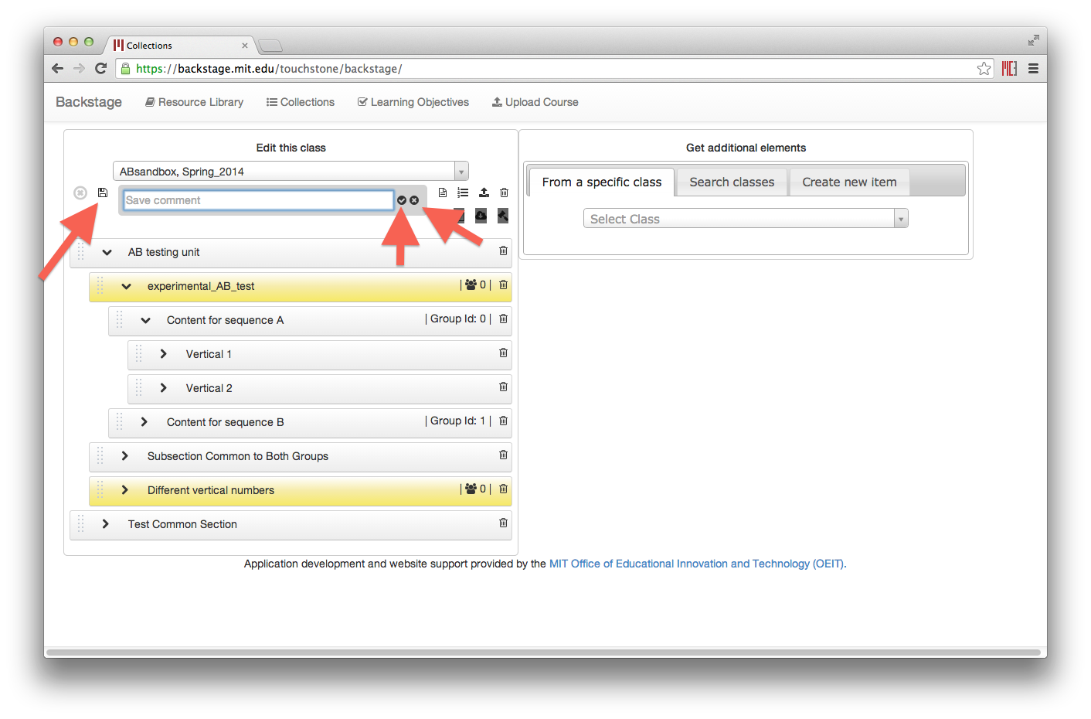



### Saving your changes

When you make any changes to a course, three icons related to downloading or copying a course will be grayed out.

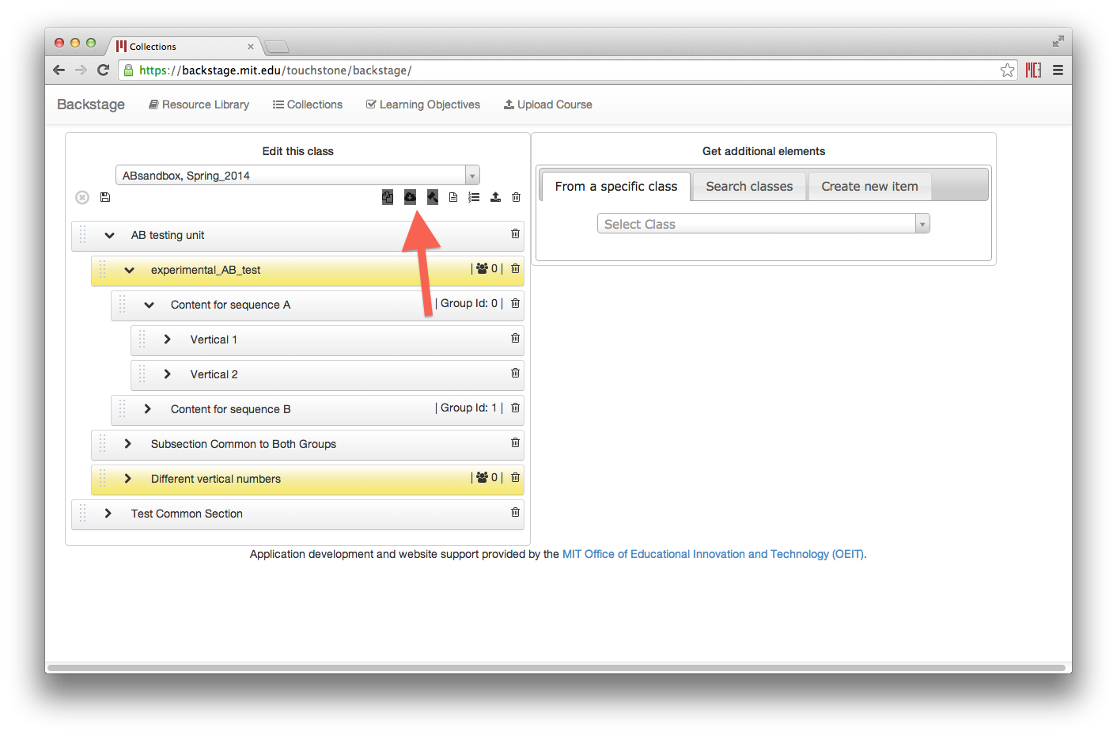

### Download to edX

To export your course from Backstage, first open it in the left-hand pane. You can then click the download icon to get a .tar.gz file that is Studio compatible.

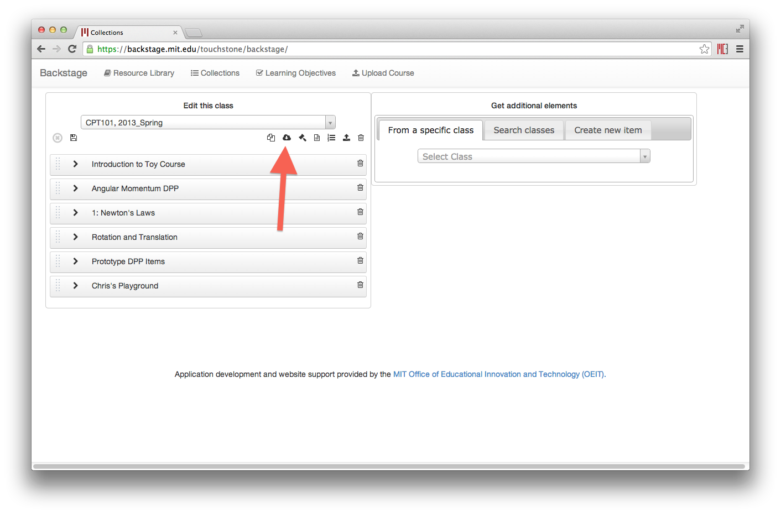

### Upload a new version

You may create a new version of your course in Studio, or make changes outside of Backstage. You can re-upload the coure to Backstage as the latest version, via the upload icon.

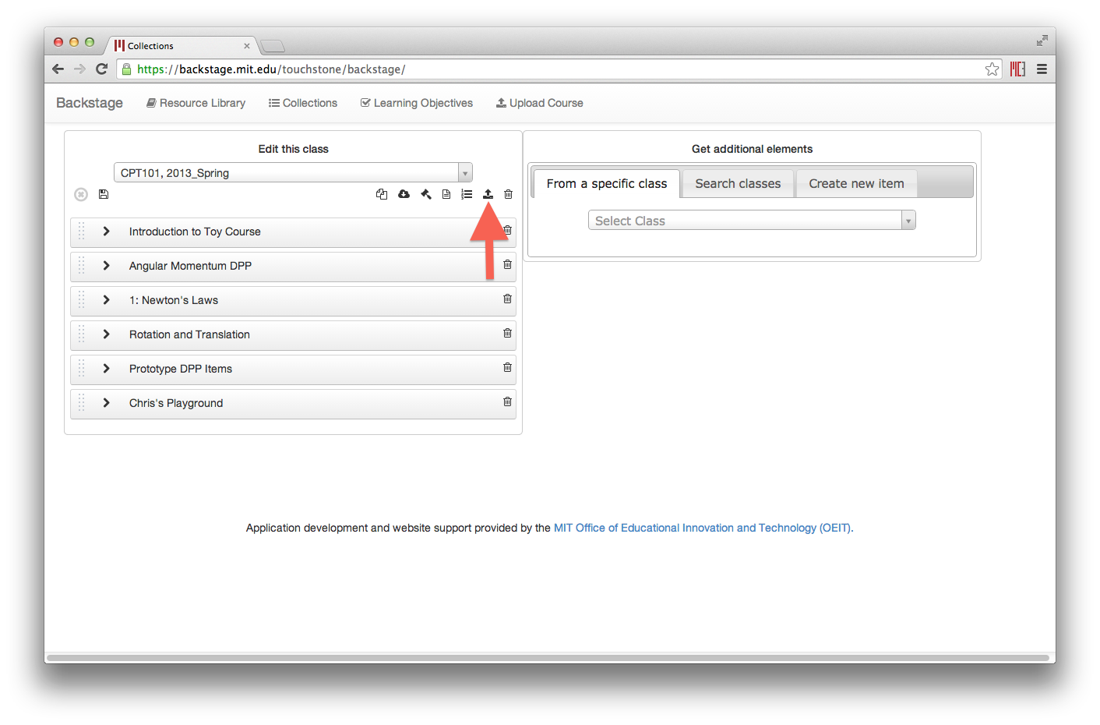

You will be prompted for the file, if you want to include Draft items, and an upload comment—fill out the comment to let others know exactly what changed or what milestone the version relates to.

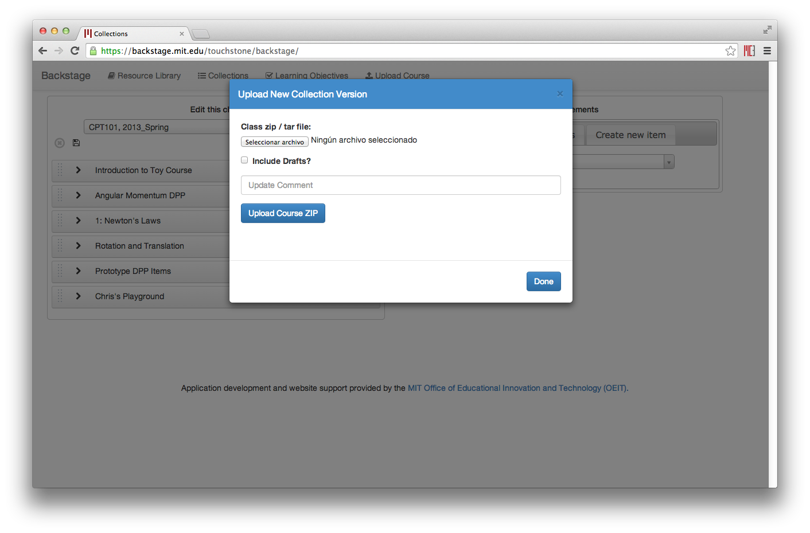

## LEARNING OBJECTIVES

This is a work in progress.

## UPLOAD COURSE

**Backstage** accepts as input either an edX class from a GitHub repository (*.zip file), or a Studio export (*.tar.gz file). It parses and captures images, content, problems, policies, chapters, sequentials, and verticals into a database. It assigns each of these items a unique ID, which allows for versioning and traceability. You can also choose to upload Draft content, which will appear in your course with a “lock” icon to indicate that it is private.

